SYSTEM ANALYSIS AND

DESIGN

UNIT – 1

System Study and System Development Life Cycle

Shree M. & N. Virani Science College (Autonomous)

ATMIYA Group of Institutions, Yogidham Gurukul, Rajkot.

Priyank Doshi

Asst. Professor (MCA, MSc.(Math) )



System Development Life Cycle

(Activities and Outcomes of Each Phase)

Shree M. & N. Virani Science College (Autonomous)

Priyank Doshi

Asst. Professor (MCA, MSc.(Math) )

ATMIYA Group of Institutions, Yogidham Gurukul, Rajkot.

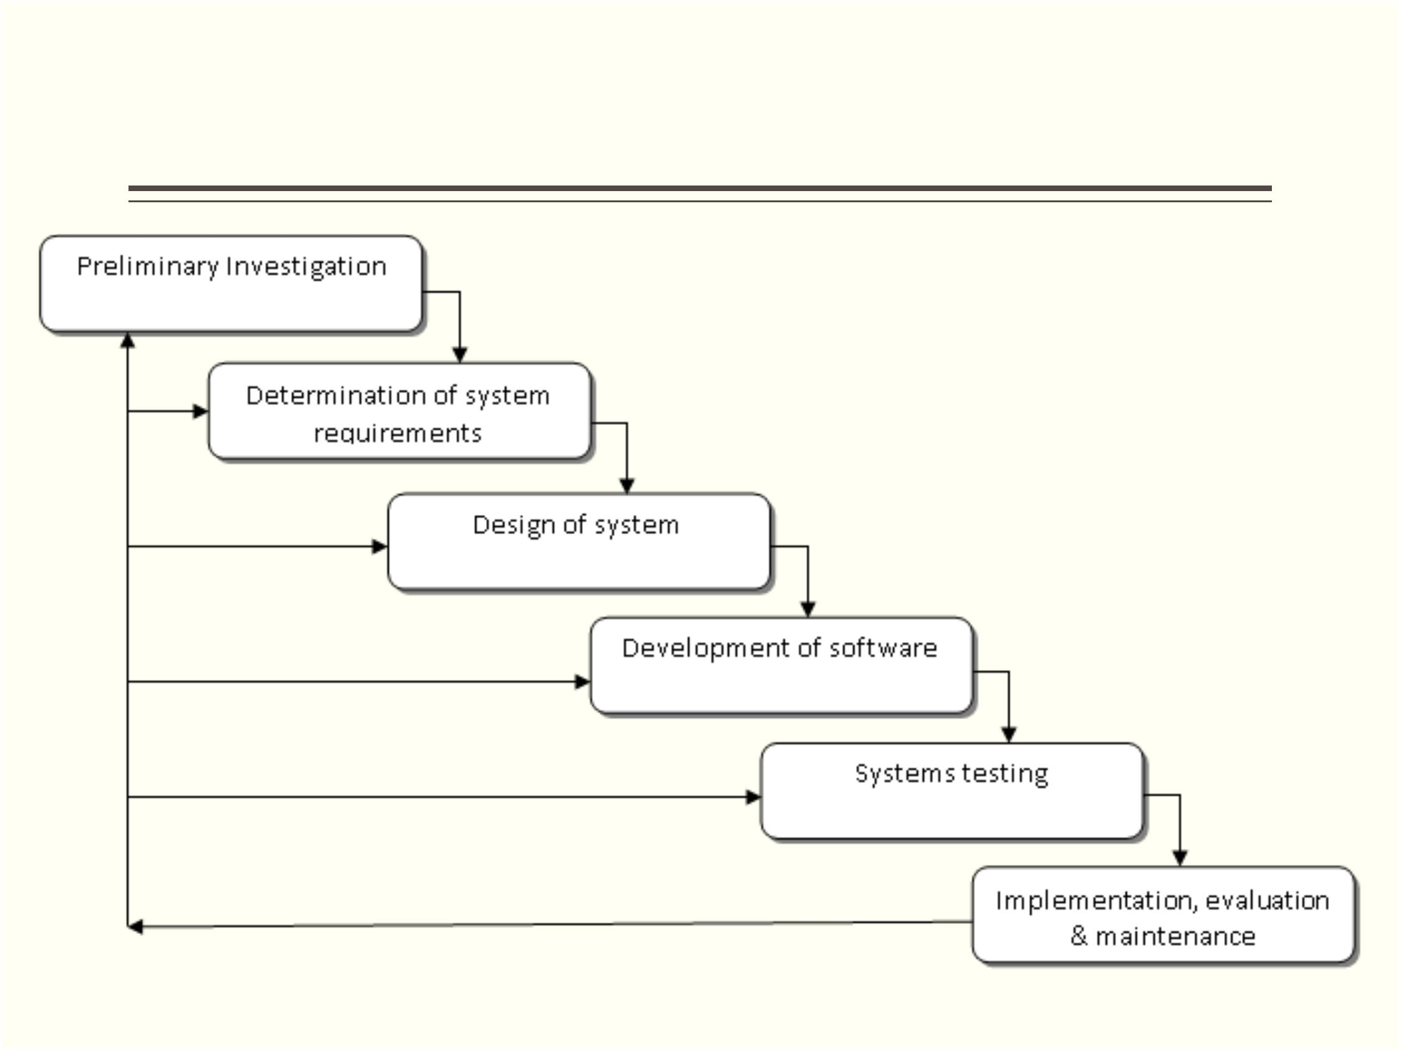

Preliminary Investigation

.

.

Request Clarification

Feasibility study

1

2

3

4

5

6

7

. Technical feasibility

. Operational feasibility

. Economic feasibility

. Social feasibility

. Management feasibility

. Legal feasibility

. Time feasibility

.

Request Approval

Shree M. & N. Virani Science College (Autonomous)

ATMIYA Group of Institutions, Yogidham Gurukul, Rajkot.

Priyank Doshi

Asst. Professor (MCA, MSc.(Math) )



Determination of System Requirements

.

.

.

Systems analysts discuss with different category of persons to

collect the facts and to study about the business process.

Data are collected using fact finding techniques like, interviews,

on-site observations and questionnaires.

Mainly data specific information can be obtained first from

documentation (manuals or reports).

Shree M. & N. Virani Science College (Autonomous)

ATMIYA Group of Institutions, Yogidham Gurukul, Rajkot.

Priyank Doshi

Asst. Professor (MCA, MSc.(Math) )



Questions can be asked while determination of system

Requirements so that necessary actions like modifying

or adding of any operations can be performed.

.

.

.

.

.

.

.

What is being done?

How is it being done?

How frequently does it occur?

How great is the volume of transactions or decisions?

How well is the task being performed?

Does a problem exist?

If a problem exists, how serious is it? What is the underlying

cause?

Shree M. & N. Virani Science College (Autonomous)

ATMIYA Group of Institutions, Yogidham Gurukul, Rajkot.

Priyank Doshi

Asst. Professor (MCA, MSc.(Math) )



Design of System

**High ?Level Design or System Desig (HLD)**

High ? level Design gives the overall System Design in terms of **Functional**

**Architecture and Database design**. This is very useful for the developers to

understand the flow of the system. In this phase design team, review team (testers)

and customers plays a major role. For this the entry criteria are the requirement

document that is SRS. And the exit criteria will be HLD, projects standards, the

functional design documents, and the database design document.

**Low ? Level Design (LLD)**

During the detailed phase, the view of the application developed during the high

level design is broken down into modules and programs. Logic design is done for

every program and then documented as **program specifications**. For every

program, a **unit test** plan is created.

The entry criteria for this will be the HLD document. And the exit criteria will the

program specification and unit test plan (LLD)

Shree M. & N. Virani Science College (Autonomous)

Priyank Doshi

Asst. Professor (MCA, MSc.(Math) )

ATMIYA Group of Institutions, Yogidham Gurukul, Rajkot.



Development of Software

.

This is also known as physical design. Software is the set of

related programs. Programmers can write programs using current

or required technology and languages. There are options of ready-

made software, custom-made software, in-house development of

system. The decision depends on available time, money and

software specification. In some software development company

outsourcing is also one of the options. Programmers also prepare

documentation of the program, providing an explanation of how and

why certain procedures are coded in specific ways. Documentation

used to test the program and carry out maintenance task.

Shree M. & N. Virani Science College (Autonomous)

ATMIYA Group of Institutions, Yogidham Gurukul, Rajkot.

Priyank Doshi

Asst. Professor (MCA, MSc.(Math) )



System Testing

.

During systems testing, the system is used experimentally to

ensure that the software does not fail. In other words, we can

say that it will run according to its specifications and in the way

users expect. Special test data are input for processing, and the

results examined. There are many methods to test software

including different levels. These levels are unit testing,

integration testing and system testing. There are many methods

in each level like white box, black box, alpha, beta, big bang etc.

Primary objective is to increase quality of software with

validation as per requirement specification document.

Shree M. & N. Virani Science College (Autonomous)

ATMIYA Group of Institutions, Yogidham Gurukul, Rajkot.

Priyank Doshi

Asst. Professor (MCA, MSc.(Math) )



Implementation, Evaluation and Maintenance

.

**Implementation** is the process of starting work with new software and new

equipment. Before we use new software we have to train users, install the

new application and construct necessary data files. Training may be

followed by test of employees who has participated in training. If

implementation carried out by direct way in which on a specific date

working on new system started and working on old system stopped. In case

of parallel implementation work on both new and old system will continue

up to a specific period of time and later working on old one has been

stopped. This gives safety from any hazard with new system. In the case of

Phase wise implementation working started with new software in a small

area of organization, errors or problems are eliminated if occur then

software implemented in other area gradually phase by phase.

Shree M. & N. Virani Science College (Autonomous)

ATMIYA Group of Institutions, Yogidham Gurukul, Rajkot.

Priyank Doshi

Asst. Professor (MCA, MSc.(Math) )



Evaluation

.

Evaluation of the system is performed to certify the system with

its strength and weakness.

.

.

.

.

Operational Evaluation

Organizational Impact

User Manager Assessment

Development Performance

Shree M. & N. Virani Science College (Autonomous)

ATMIYA Group of Institutions, Yogidham Gurukul, Rajkot.

Priyank Doshi

Asst. Professor (MCA, MSc.(Math) )



Maintenance

.

.

Corrective: - Errors are removed when arise for quality

improvement.

Adaptive: - Externally when we change operating system, or install

new device we have to modify our software to adapt these

changes.

.

.

Perfective: - To increase profit of the organization or to get

additional benefits additional functionalities are added in the

requirement specification set.

Preventive: - This type of modification in software gives ease in

above three type of maintenance.

Shree M. & N. Virani Science College (Autonomous)

ATMIYA Group of Institutions, Yogidham Gurukul, Rajkot.

Priyank Doshi

Asst. Professor (MCA, MSc.(Math) )

